Depiction how to run and process and view desired output in a clean Linux environment:

1. a. Open bash which is a default shell for Linux.

b. Enter following commands

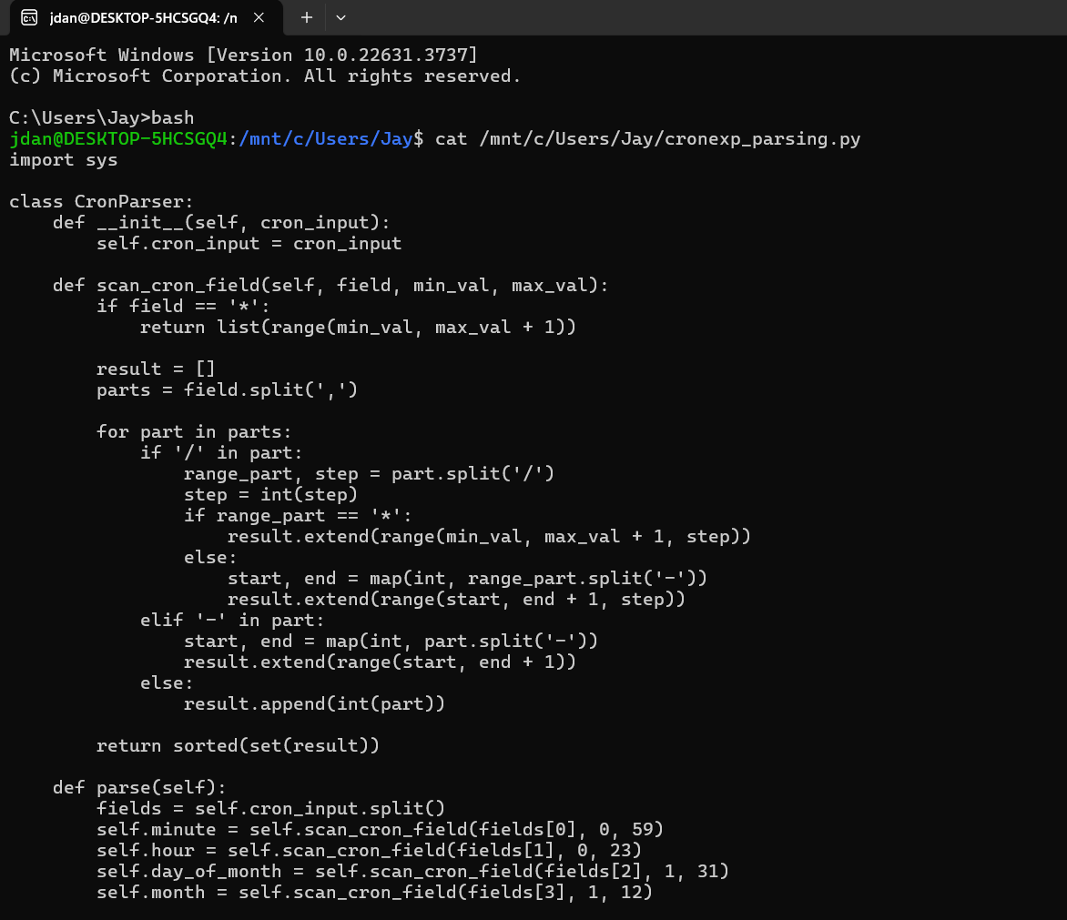

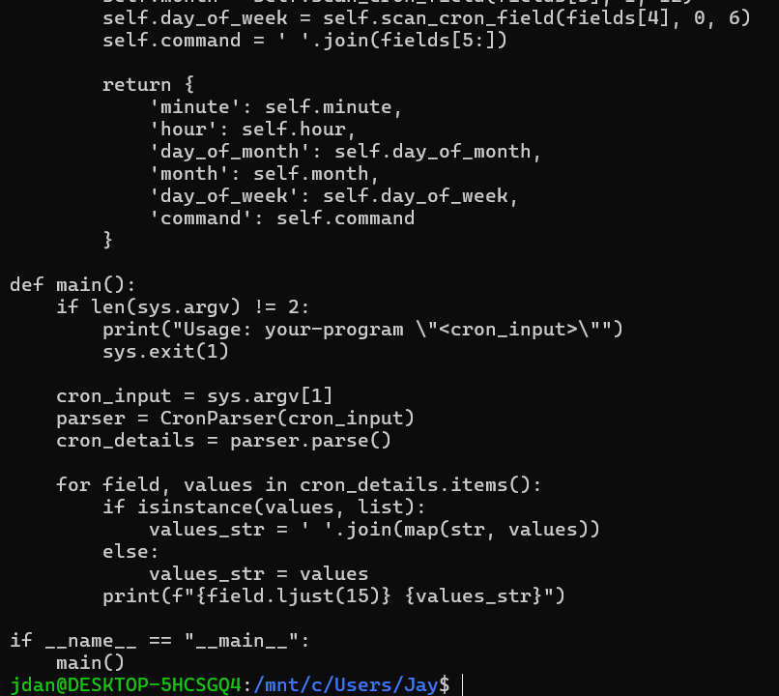

1. After viewing script, now we run it using command as shown below:

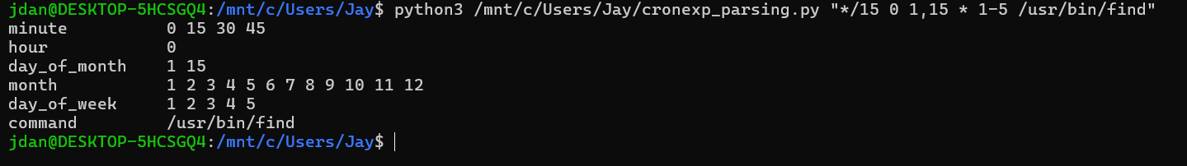

1. Checked whether output generated matches the desired output exactly.  
   Result: Exact match.
2. Optional step to check accuracy of script with another cron expression:

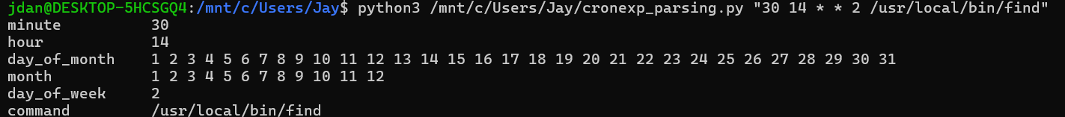

Output generated is as expected.